UNIT 1

**I. What is I/O Psychology?**

Industrial and organizational psychology (I-O psychology), an applied discipline within [psychology](https://en.wikipedia.org/wiki/Psychology), is the science of [human behaviour](https://en.wikipedia.org/wiki/Human_behavior) in the [workplace](https://en.wikipedia.org/wiki/Workplace).

I-O [psychologists](https://en.wikipedia.org/wiki/Psychologist) are trained in the [scientist–practitioner model](https://en.wikipedia.org/wiki/Scientist%E2%80%93practitioner_model). As an applied field, the discipline involves both research and practice and I-O psychologists apply psychological theories and principles to organizations and the individuals within them. They contribute to an organization's success by improving the [job performance](https://en.wikipedia.org/wiki/Job_performance), [wellbeing](https://en.wikipedia.org/wiki/Well-being), [motivation](https://en.wikipedia.org/wiki/Motivation), [job satisfaction](https://en.wikipedia.org/wiki/Job_satisfaction) and the [health and safety](https://en.wikipedia.org/wiki/Health_and_safety) of employees.

Industrial-organizational psychology have two major sides. First, there is the industrial side, which involves looking at how to best match individuals to specific job roles. This segment of I-O psychology is also sometimes referred to as personnel psychology.

The organizational side of psychology is more focused on understanding how organizations affect individual behaviour. Organizational structures, social norms, management styles, and role expectations are all factors that can influence how people behave within an organization.

**Six Key Subject Areas**

* **Employee selection**: This area involves developing employee selection assessments, such as screening tests to determine if job applicants are qualified for a particular position.
* **Ergonomics:** The field of ergonomics involves designing procedures and equipment designed to maximize performance and minimize injury.
* **Organizational development**: I-O psychologists who work in this area help improve organizations, often through increasing profits, redesigning products, and improving the organizational structure.1﻿
* **Performance management:** I-O psychologists who work in this area develop assessments and techniques to determine if employees are doing their jobs well.
* Training and development: Professional in this area often determine what type of skills are necessary to perform specific jobs as well as develop and evaluate employee training programs.
* **Work life**: This area focuses on improving employee satisfaction and maximizing the productivity of the workforce. I-O psychologists in this area might work to find ways to make jobs more rewarding or design programs that improve the quality of life in the workplace.

**Industrial-Organizational Psychology Topics**

Here are some of the specific topics addressed by industrial-organizational psychology experts:

* **Employee motivation:** Professionals in this field may also use psychological principles to help keep workers motivated.
* **Employee testing:** Psychological principles and tests are often used by I-O psychologists to help businesses select candidates that are best-suited to specific job roles.
* [**Leadership**](https://www.verywellmind.com/leadership-styles-2795312)**:** I-O psychologists may work to help leaders develop better strategies or train managers to utilize different leadership skills to manage team members more effectively.
* **Product design**: Some I-O psychologists are involved in the development of consumer or workplace products.
* **Workplace diversity:** Within the area of organizational psychology, professionals in this field may help businesses develop hiring practices that foster greater diversity as well as train employees on diversity and inclusion.
* **Workplace performance**: I-O psychologists often study behaviour in the workplace in order to design environments and procedures that maximize employee performance.

**II. What is Research?**

Research is "creative and systematic work undertaken to increase the stock of knowledge" It involves the collection, organization and analysis of evidence to increase understanding of a topic.

**Research Methods**

Research methods are the strategies, processes or techniques utilized in the collection of data or evidence for analysis in order to uncover new information or create better understanding of a topic.

There are different types of research methods which use different tools for data collection.

**Qualitative Research** gathers data about lived experiences, emotions or behaviours, and the meanings individuals attach to them. It assists in enabling researchers to gain a better understanding of complex concepts, social interactions or cultural phenomena. This type of research is useful in the exploration of how or why things have occurred, interpreting events and describing actions.

**Quantitative Research** gathers numerical data which can be ranked, measured or categorised through statistical analysis. It assists with uncovering patterns or relationships, and for making generalisations. This type of research is useful for finding out how many, how much, how often, or to what extent.

**Mixed Methods Research** integrates both Q**ualitative**and**Quantitative Research**. It provides a holistic approach combining and analysing the statistical data with deeper contextualised insights. Using Mixed Methods also enables **Triangulation,** or verification, of the data from two or more sources.

| **Qualitative Techniques or Tools** | **Quantitative Techniques or Tools** |
| --- | --- |
| Interviews: these can be structured, semi-structured or unstructured in-depth sessions with the researcher and a participant. | Surveys or questionnaires: which ask the same questions to large numbers of participants or use Likert scales which measure opinions as numerical data. |
| Focus groups: with several participants discussing a particular topic or a set of questions. Researchers can be facilitators or observers. | Observation: which can either involve counting the number of times a specific phenomenon occurs, or the coding of observational data in order to translate it into numbers. |
| Observations: On-site, in-context or role-play options. | Document screening: sourcing numerical data from financial reports or counting word occurrences. |
| Document analysis: Interrogation of correspondence (letters, diaries, emails etc) or reports. | Experiments: testing hypotheses in laboratories, testing cause and effect relationships, through field experiments, or via quasi- or natural experiments. |
| Oral history or life stories: Remembrances or memories of experiences told to the researcher. |  |

**III. Statistics**

Statistics is the discipline that concerns the collection, organization, analysis, interpretation, and presentation of [data](https://en.wikipedia.org/wiki/Data). In applying statistics to a scientific, industrial, or social problem, it is conventional to begin with a [statistical population](https://en.wikipedia.org/wiki/Statistical_population) or a [statistical model](https://en.wikipedia.org/wiki/Statistical_model) to be studied.

Two main statistical methods are used in data analysis: descriptive statistics, which summarizes data using indexes such as mean and median and another is inferential statistics, which draw conclusions from data using statistical tests

**IV. Evidence-based Practice**

 Evidence-based practice (EBP) aims to maximize the effectiveness of psychological interventions through adherence to principles informed by empirical findings, clinical expertise, and client characteristics.

Evidence-based practice is a process that involves five distinct steps which we call the five 'A's: Ask, Access, Appraise, Apply, Audit.

**V. Context of Industrial Psychology**

Industrial and organizational psychologists work in four main contexts: academia, government, consulting firms, and business

**VI. Job analysis**

Job analysis is a fundamental part of the practice of industrial/organizational psychology. Analyzing a job involves the determination of what tasks make up a job, the tasks’ relative importance, and what knowledge, skills, and abilities are necessary to successfully carry out those tasks.  Job analysis results may be utilized for a variety of personnel management purposes but are especially important for selection and promotional decisions.  Job analysis is undertaken prior to selection and promotional testing in order to determine what attributes qualify an individual for a specific job.  In other words, the aspects identified through comprehensive job analysis serve as the criteria for tests and other assessments used in selection or promotion.

**VII. Competency model**

A competency model is a collection of competencies that together define successful performance in a particular work setting. Competency models are the foundation for important human resource functions such as recruitment and hiring, training and development, and performance management.

**VIII. Job Evaluation**

A job evaluation is a systematic way of determining the value/worth of a job in relation to other jobs in an organization. It tries to make a systematic comparison between jobs to assess their relative worth for the purpose of establishing a rational pay structure. There are 4 methods of job evaluation and they are:

1. **The point method** evaluates jobs by comparing compensable factors - elements of job content like skill, effort or responsibility that can be used to assess a job's value to the organization. Each factor is defined and assigned a range of points based on the factor's relative importance to the organization.

2. **Factor comparison** is a process that human resources professionals use to evaluate and compare different job candidates. By evaluating factors such as education, experience, skills, and qualifications, human resources professionals can identify the best candidates for a given position.

3. **Ranking Method** is the simplest form of [**job evaluation method**](https://www.mbaknol.com/human-resource-management/methods-of-job-evaluation/). The method involves ranking each job relative to all other jobs, usually based on some overall factor like ‘job difficulty’. Each job as a whole is compared with other and this comparison of jobs goes on until all the [jobs have been evaluated](https://www.mbaknol.com/human-resource-management/job-evaluation-process/) and ranked. All jobs are ranked in the order of their importance from the simplest to the hardest or from the highest the lowest. The importance of order of job is judged in terms of duties, responsibilities sand demands on the job holder.

4. A **job grade** is defined as a group of different jobs of similar difficulty or requiring similar skills to perform them. Job grades are determined on the basis of information derived from job analysis. The grades or classes are created by identifying some common denominator such as skills, knowledge and responsibilities.

**IX. Compensation**

This process involves using internal and external data to determine what a given position's salary range should be, what related positions should pay, and what benefits are appropriate for a given job.

**X. Job Design**

Job design refers to what, how much, how many, and the order of the tasks for a job. It organizes the job’s tasks and functionalities for maintaining better [relationships among the levels of the organizational chain](https://www.iedunote.com/3-levels-of-management-organizational-hierarchy). Job design is important in management, [organizational behavior](https://www.iedunote.com/organizational-behavior), and [human resource management](https://www.iedunote.com/human-resource-management).

## 10 Factors Affecting Job Design

## a. Organizational Factors Affecting Job Design

Organizational factors that affect job design include work nature or characteristics, workflow, organizational practices, and ergonomics.

### 1. **Work Nature**

There are various job elements, and job design is required to classify tasks into a job or a coherent set of jobs. The various tasks may be planning, executing, monitoring, controlling, etc., and all these are to be considered while designing a job.

### **2. Ergonomics**

Ergonomics aims to design jobs so that employees’ physical abilities and individual traits are considered to [ensure efficiency and productivity](https://www.iedunote.com/effectiveness-efficiency-productivity-management).

### **3. Workflow**

Product and service type often determines the sequence of a workflow. A balance is required between the various product or service processes, and a job design ensures this.

### **4. Culture**

[Organizational culture](https://www.iedunote.com/organizational-culture) determines the way tasks are carried out at the workplace. Practices are methods or standards laid out for carrying out a certain task. These practices often affect the job design, especially when the practices are not aligned with the interests of the unions.

## b. Environmental Factors Affecting Job Design

[Environmental factors](https://www.iedunote.com/organizational-environment-elements) affect job design to a considerable extent. These factors include both internal as well as external factors.

They include employee skills and abilities, availability, and socio-economic and cultural prospects.

### **1. Employee availability and abilities**

[Employee skills](https://www.iedunote.com/managerial-skills), abilities, and availability play a crucial role in designing jobs. The factors mentioned above of employees who will perform the job are considered.

Designing a more demanding [job and above their skill set will lead to decreased productivity and employee satisfaction](https://www.iedunote.com/job-satisfaction-components).

### **2. Socio-economic and cultural expectations**

Jobs are nowadays becoming more employee-centered rather than process-centered. They are, therefore, designed to keep the employees into consideration.

In addition, the literacy level among the employees is also on the rise. They now demand jobs that are to their liking and competency and in which they can perform the best.

## c. Behavioral Factors Affecting Job Design

Behavioral factors or human factors pertain to human needs and need to be satisfied to ensure productivity at the workplace.

They include elements like autonomy, diversity, feedback, etc. A brief explanation of them is given below:

### **1. Autonomy**

Employees should work in an open environment rather than one that contains fear. It promotes creativity and independence and leads to increased efficiency.

### **2. Feedback**

Feedback should be an integral part of the work. Each employee should receive proper feedback about individual work performance.

### **3. Diversity**

Job variety/diversity should be given due importance while designing a job. A job should have sufficient diversity and variety to remain interesting with every passing day. Repetitive jobs often make work monotonous, which leads to boredom.

### **4. Use of Skills and abilities**

Jobs should be employee rather than process-centered. Though due emphasis needs to be given to the latter, jobs should be designed so that an employee can fully use his abilities and perform the job effectively.

## 4 Benefits of Job Design

### **Employee Input**

A good job design enables good job feedback. Employees can choose various tasks per their workplace’s personal and social needs, habits, and circumstances.

### **Employee Training**

Training is an integral part of job design. Contrary to the philosophy of “leave them alone,” job design emphasizes training people to know their job demands and how they should be done.

### **Work/Rest Schedules**

Job design offers good work and rest schedules by clearly defining an individual’s hours in their job.

### **Adjustments**

A good job design allows for physically demanding jobs by minimizing the energy spent doing the job and aligning the human resources requirements.

Job design is a continuous and ever-evolving process aimed at helping employees adjust to workplace changes. The end goal is to reduce dissatisfaction and enhance motivation and [employee engagement](https://www.iedunote.com/labor-management-cooperation) at the workplace.

## 5 Techniques of Job Design

Job enlargement, job enrichment, job rotation, and job simplification are the various techniques used in job design exercises.

A well-designed job will encourage a variety of good body positions, have reasonable strength requirements, require a fair amount of mental activity, and help foster achievement and self-esteem.

Achieving good job design involves administrative practices that determine what the employee does, for how long, where, and when, and giving the employees a choice where ever possible.

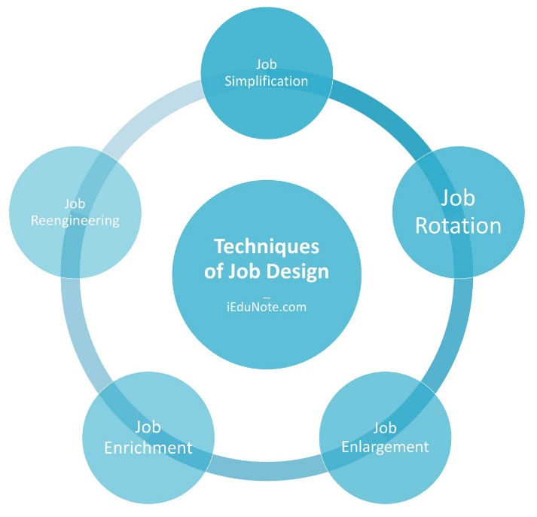

**XI. Recruitment**

Recruitment refers to the process of identifying, attracting, interviewing, selecting, hiring and onboarding employees. In other words, it involves everything from the identification of a staffing need to filling it. Depending on the size of an organization, recruitment is the responsibility of a range of workers.